PROJECT 5

Smart Traffic Light

Date September 7, 2026

GitHub: github.com/arlengj995-bit

This project models two vehicle signal groups representing North-South and East-West traffic. Timed states alternate them. A pedestrian interrupt records a request, which the main loop processes to set both groups red and turn on the walk LED for four seconds.

1. What This Project Does
This project controls a set of traffic lights at a four-way intersection. There are two traffic lights, one for North-South traffic and one for East-West traffic. They take turns: when North-South is green, East-West is red, and vice versa. The lights change automatically on a timer.
The interrupt records a pedestrian request. The main loop then changes both groups to red and turns on WALK for four seconds. Additional requests during pedestrian mode are discarded without restarting its timer. The cycle then restarts at NS green.
Earlier projects used delay(), which blocks the main program. Hardware interrupts can still run during that delay, but the main loop cannot process a request until the delay ends. Here millis() tracks elapsed time while the main loop keeps running.
This is the fifth of ten projects building toward an automated aquarium controller. The state machine pattern I learned here is exactly what I will use in the aquarium controller. The aquarium has different modes depending on time of day (lights on, CO₂ on, night mode). The millis() non-blocking timing is also required in the capstone because the aquarium controller needs to monitor temperature, check pH, watch the clock, and respond to alerts all at the same time, it cannot freeze while waiting for any one thing.

2. Four New Concepts in This Project

2.1 Finite State Machine (FSM)
A Finite State Machine is a way of organizing a program so it can only be in one defined condition at a time. Each condition is called a state. The program moves between states based on rules.
Without this idea, a traffic light program gets messy quickly. One end up with lots of if statements tangled together and it gets hard to add new features without breaking something. With a state machine, each state is separate and clear. Adding the pedestrian feature only required adding one new state and a few rules. Nothing else changed.
My traffic light has five states:
State | Duration | What happens
NS_GREEN | 5 seconds | North-South green, East-West red
NS_YELLOW | 2 seconds | North-South yellow, East-West red
EW_GREEN | 5 seconds | East-West green, North-South red
EW_YELLOW | 2 seconds | East-West yellow, North-South red
PEDESTRIAN | 4 seconds | All traffic red, walk signal on

The design has five named states and stores one current state. A finite state machine makes behavior explicit but does not guarantee correctness; implementation and testing are still required.

2.2 enum, giving names to states
enum is a way to give names to things instead of using numbers. Without enum, I would have to write things like if (state == 2), which does not make it obvious what state 2 means. With enum I can write if (state == EW_GREEN), which is immediately clear.
enum TrafficState {
NS_GREEN_STATE, // = 0 automatically
NS_YELLOW_STATE, // = 1
EW_GREEN_STATE, // = 2
EW_YELLOW_STATE, // = 3
PEDESTRIAN_STATE // = 4
};

TrafficState currentState = NS_GREEN_STATE;
The compiler converts the names to numbers (0, 1, 2, 3, 4) automatically. I never need to use or even know those numbers. The code reads like a description of what the system is doing.

2.3 millis() for non-blocking timing
delay() blocks ordinary program execution but does not disable hardware interrupts. An ISR can record a request during a delay; the main loop must wait until execution resumes to act on it.
millis() solves this. Instead of telling the program to stop and wait, I record what time the current state started. Then every time loop() runs, I check how much time has passed. If enough time has passed, I move to the next state. If not, loop() finishes and runs again immediately.
delay(5000) says: stop here for 5 seconds, do nothing else.
millis() says: remember when I started, check the clock every loop, move on when 5 seconds have passed.
The loop repeatedly checks elapsed time and the request flag. The ISR captures the event; the main loop changes the state and LEDs afterward. Loop frequency and response latency were not instrumented.

2.4 Hardware interrupt
Discarding requests during pedestrian mode suppresses many repeated events but is not general stable-state debounce.
When interrupts are enabled, a falling edge on D2 invokes the ISR without waiting for main-loop polling. The ISR sets pedRequest; it does not change LEDs. The main loop performs the transition afterward. Interrupt masking or other ISR activity can affect service timing.
My ISR is as short as possible. It just sets a flag to true:
volatile bool pedRequest = false;
void pedestrianRequest() {
pedRequest = true; // Set the flag -- loop() will see it next iteration
}

// In setup():
attachInterrupt(digitalPinToInterrupt(PED_BTN), pedestrianRequest, FALLING);
// FALLING means: trigger when pin 2 goes from HIGH to LOW (button pressed)
volatile tells the compiler that pedRequest may change outside the normal execution flow. It does not debounce the input or make a sequence of reading and clearing the flag.
Pin 2 was chosen because it is one of only two pins on the Arduino UNO that support hardware interrupts (pins 2 and 3).

3. State Diagram
This simplified model goes directly from a vehicle phase to all-red plus WALK without a yellow transition or clearance interval. It does not independently control turn movements. Requests during pedestrian mode are discarded; afterward the cycle restarts at NS green.
Before writing any code I drew the complete state diagram. Every state is a box. Every transition is an arrow. Every timing condition is a label on the arrow.
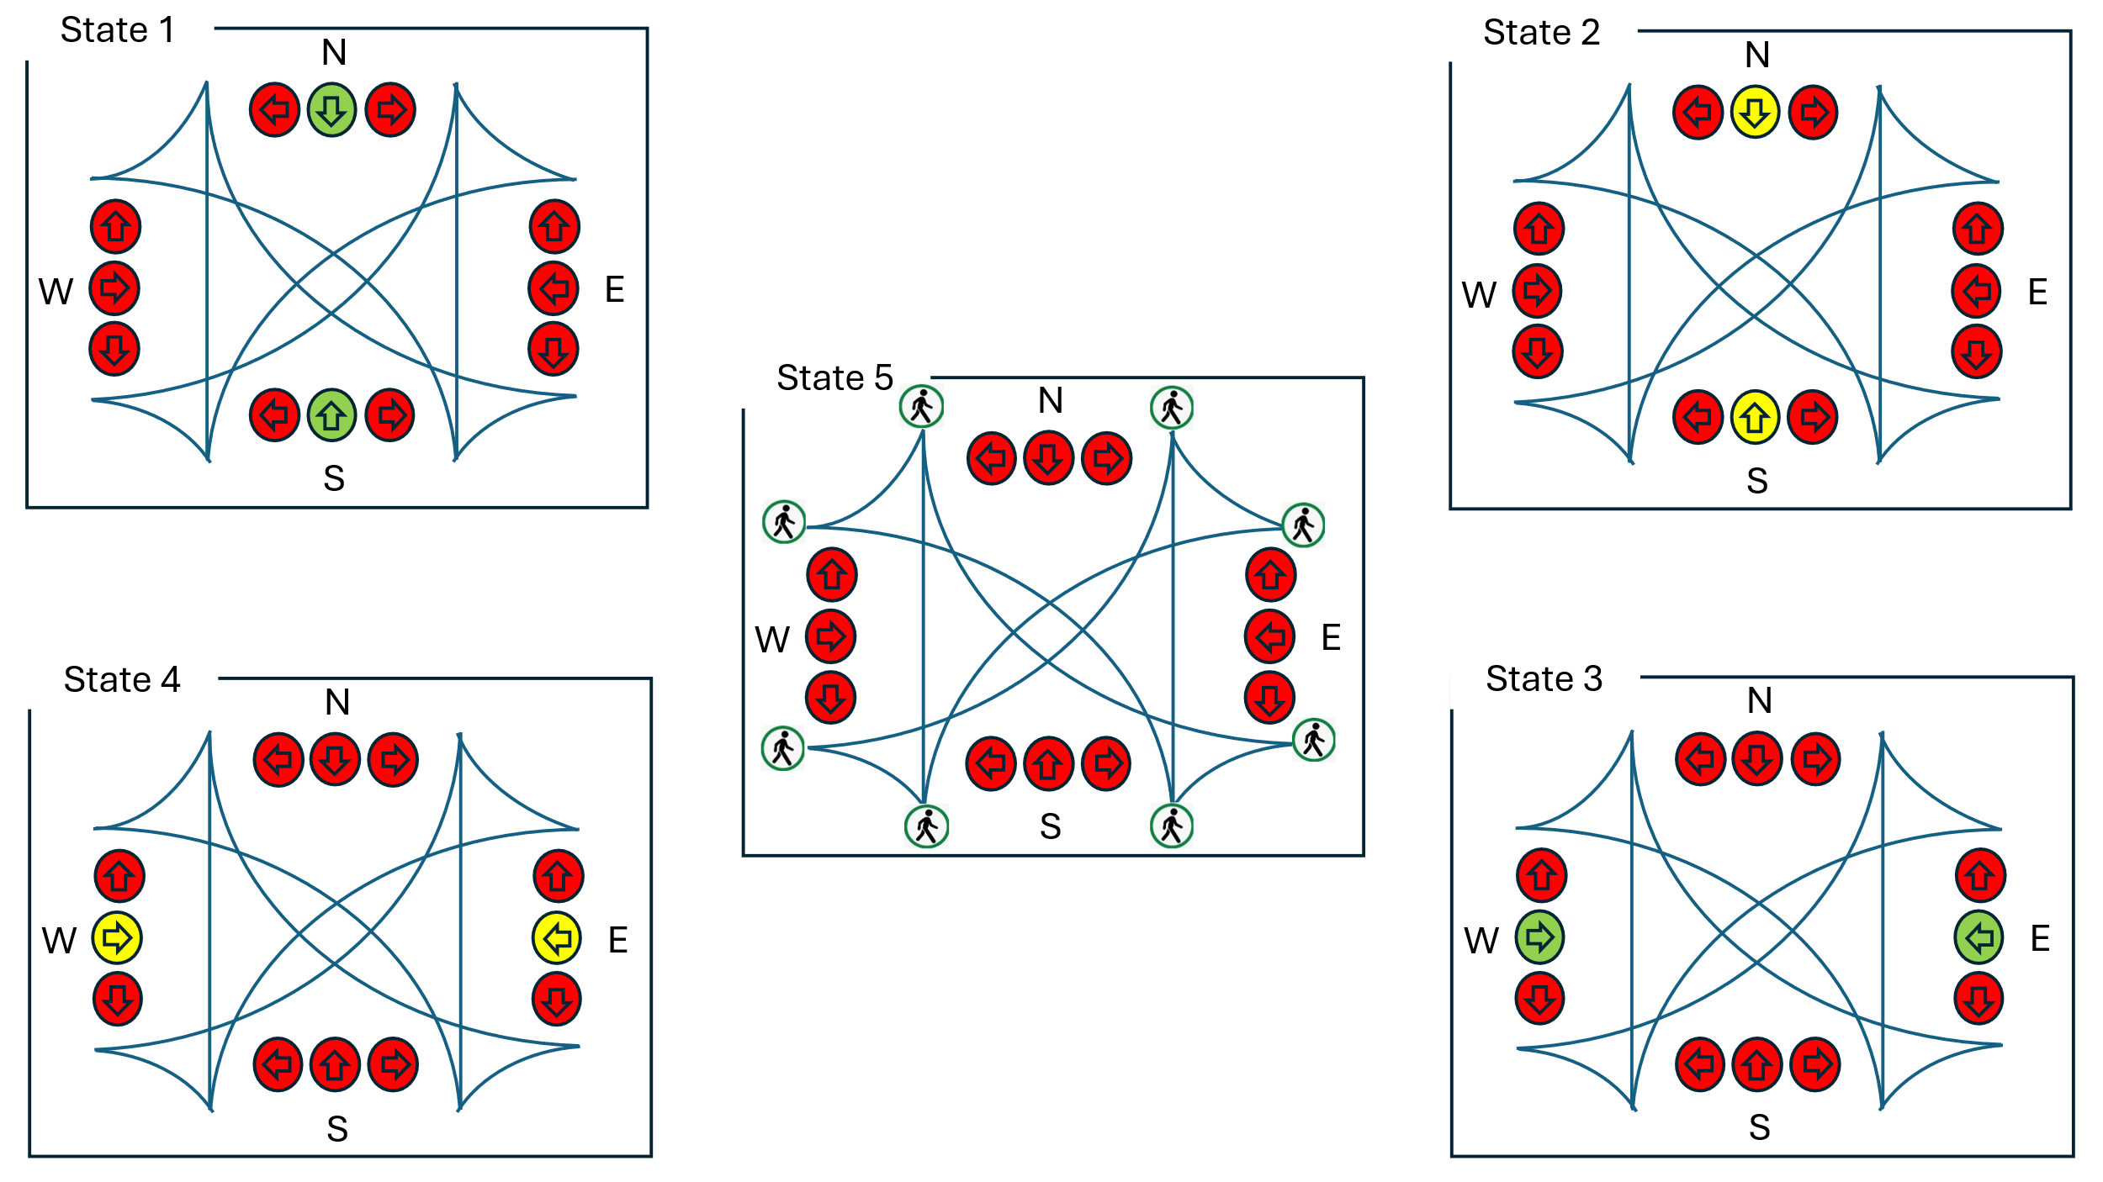

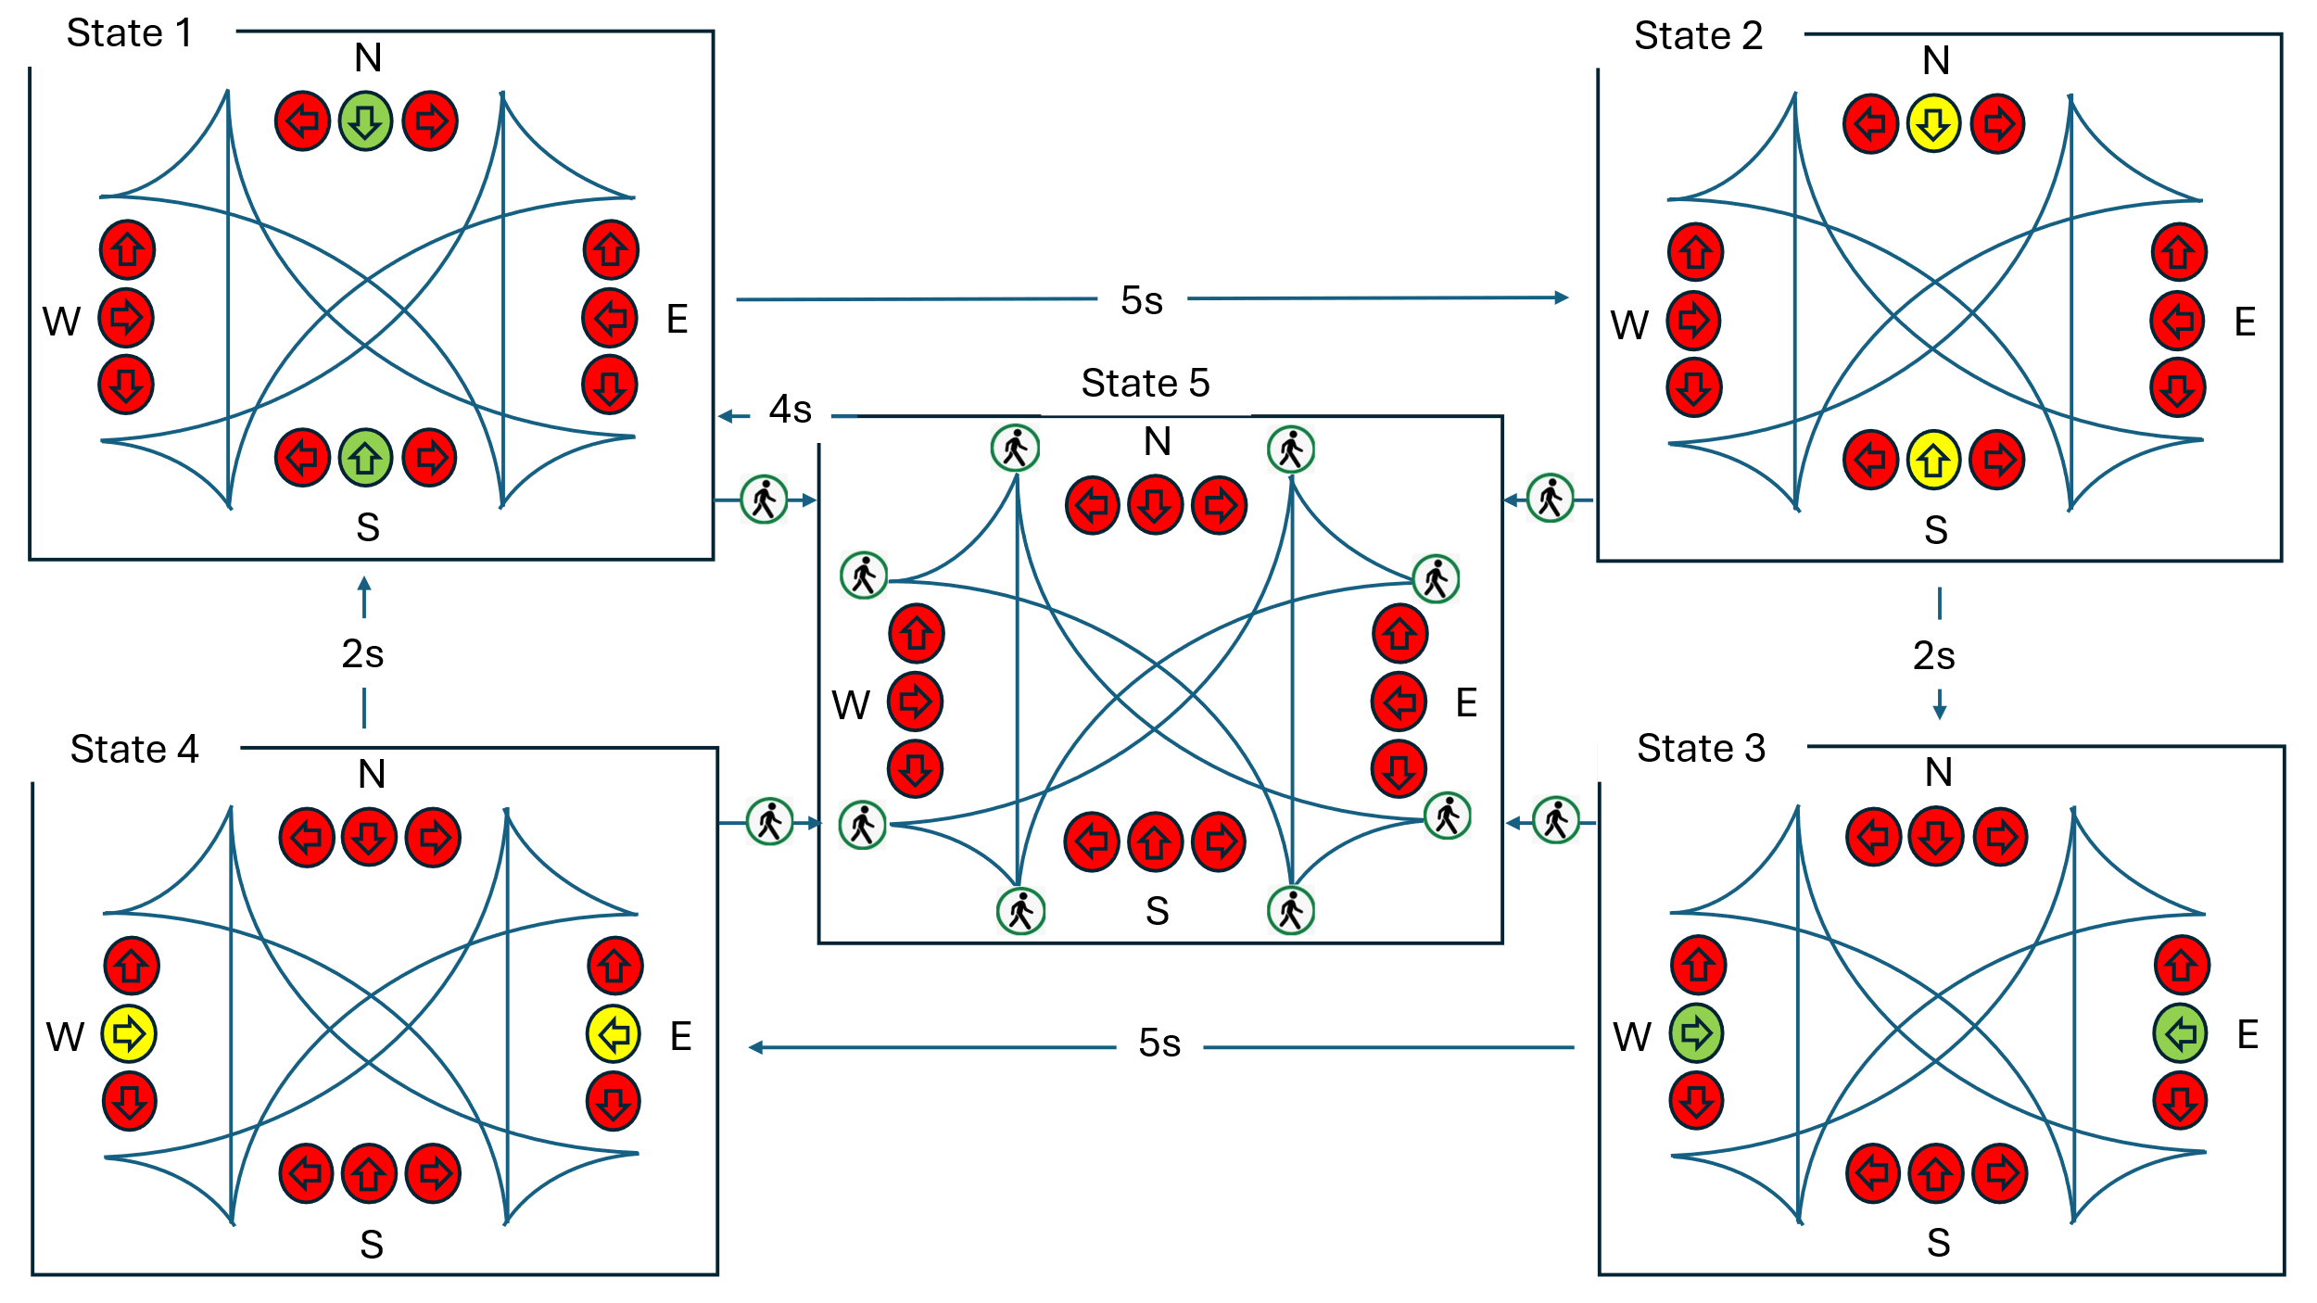

Normal cycle (no button press):
NS_GREEN (5s) → NS_YELLOW (2s) → EW_GREEN (5s) → EW_YELLOW (2s) → NS_GREEN ...
Button interrupt (from any state):
Any vehicle state + request → PEDESTRIAN (4 s) → NS_GREEN. Requests during PEDESTRIAN are discarded without extending its duration.

Drawing the diagram first clarified the intended transitions. The code still needs checking and testing. Turn arrows in the intersection artwork are illustrative; the two LED groups do not independently control turn movements.
LED output for each state
State | NS Red | NS Yellow | NS Green | EW Red | EW Yellow | EW Green
NS_GREEN | - | - | ON | ON | - | -
NS_YELLOW | - | ON | - | On | - | -
EW_GREEN | ON | - | - | - | - | ON
EW_YELLOW | ON | - | - | - | ON | -
PEDESTRIAN | ON | - | - | ON | - | -

The Walk LED (pin 10) is only on during PEDESTRIAN state. All other states it is off. I did not add it to the table to keep it readable.

4. Components
Components: one UNO R3-compatible board; two red, two yellow, two green, and one white LED; seven 220 Ω resistors; one push button; one breadboard; jumper wires; and a USB cable.
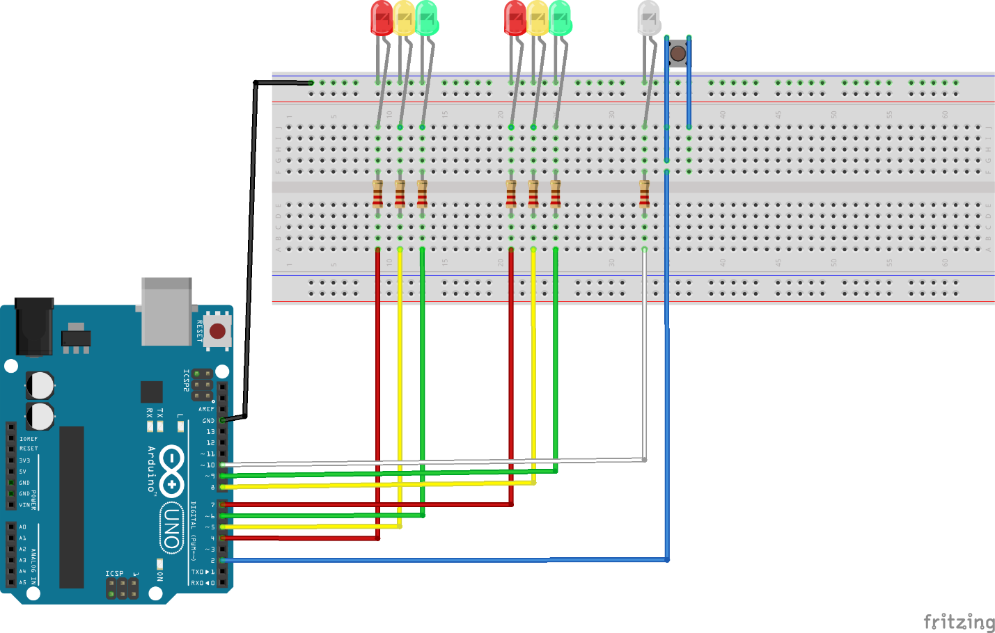

5. Circuit Design
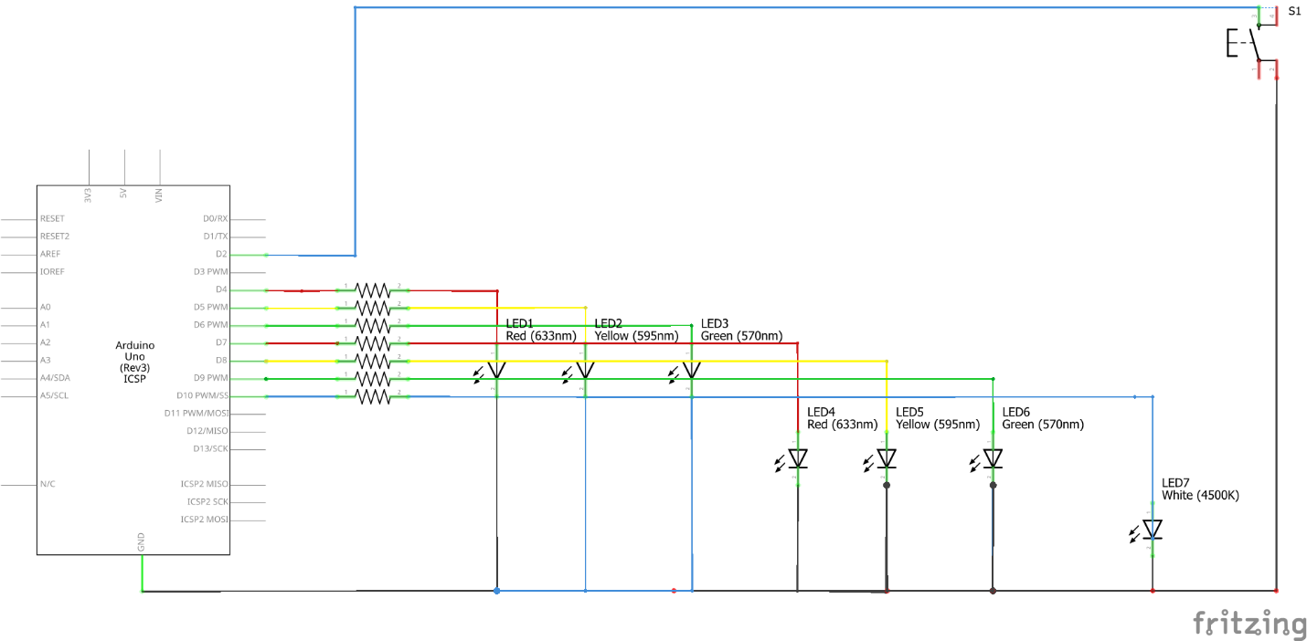
Each of the seven LEDs has a 220 Ω series resistor to limit current. Arduino specifies 20 mA per UNO I/O pin; 40 mA is not an operating-current target. Actual LED current depends on its forward voltage and resistor value.

6. How the Code Works
The final sketch separates LED output control, state selection, interrupt request capture, initialization, and the main loop. The complete final sketch is included below.
const int NS_RED = 4;
const int NS_YELLOW = 5;
const int NS_GREEN = 6;
const int EW_RED = 7;
const int EW_YELLOW = 8;
const int EW_GREEN = 9;
const int WALK_LED = 10;
const int PED_BTN = 2; // Pin 2 supports hardware interrupts
enum TrafficState {
NS_GREEN_STATE, // State 1
NS_YELLOW_STATE, // State 2
EW_GREEN_STATE, // State 3
EW_YELLOW_STATE, // State 4
PEDESTRIAN_STATE // State 5
};
TrafficState currentState = NS_GREEN_STATE;
const unsigned long GREEN_DURATION = 5000; // 5 seconds
const unsigned long YELLOW_DURATION = 2000; // 2 seconds
const unsigned long PED_DURATION = 4000; // 4 seconds
unsigned long stateStartTime = 0;
volatile bool pedRequest = false;
void pedestrianRequest() {
pedRequest = true;
}
void allOff() {
digitalWrite(NS_RED, LOW);
digitalWrite(NS_YELLOW, LOW);
digitalWrite(NS_GREEN, LOW);
digitalWrite(EW_RED, LOW);
digitalWrite(EW_YELLOW, LOW);
digitalWrite(EW_GREEN, LOW);
digitalWrite(WALK_LED, LOW);
}
void applyState(TrafficState state) {
allOff();
switch (state) {
case NS_GREEN_STATE:
digitalWrite(NS_GREEN, HIGH);
digitalWrite(EW_RED, HIGH);
break;
case NS_YELLOW_STATE:
digitalWrite(NS_YELLOW, HIGH);
digitalWrite(EW_RED, HIGH);
break;
case EW_GREEN_STATE:
digitalWrite(EW_GREEN, HIGH);
digitalWrite(NS_RED, HIGH);
break;
case EW_YELLOW_STATE:
digitalWrite(EW_YELLOW, HIGH);
digitalWrite(NS_RED, HIGH);
break;
case PEDESTRIAN_STATE:
digitalWrite(NS_RED, HIGH);
digitalWrite(EW_RED, HIGH);
digitalWrite(WALK_LED, HIGH);
break;
}
}
TrafficState nextState(TrafficState state, unsigned long elapsed) {
if (state == PEDESTRIAN_STATE) {
pedRequest = false;
if (elapsed >= PED_DURATION) {
return NS_GREEN_STATE;
}
return PEDESTRIAN_STATE;
}
if (pedRequest) {
pedRequest = false;
return PEDESTRIAN_STATE;
}
switch (state) {
case NS_GREEN_STATE:
if (elapsed >= GREEN_DURATION) {
return NS_YELLOW_STATE;
}
break;
case NS_YELLOW_STATE:
if (elapsed >= YELLOW_DURATION) {
return EW_GREEN_STATE;
}
break;
case EW_GREEN_STATE:
if (elapsed >= GREEN_DURATION) {
return EW_YELLOW_STATE;
}
break;
case EW_YELLOW_STATE:
if (elapsed >= YELLOW_DURATION) {
return NS_GREEN_STATE;
}
break;
case PEDESTRIAN_STATE:
break;
}
return state;
}
void setup() {
pinMode(NS_RED, OUTPUT);
pinMode(NS_YELLOW, OUTPUT);
pinMode(NS_GREEN, OUTPUT);
pinMode(EW_RED, OUTPUT);
pinMode(EW_YELLOW, OUTPUT);
pinMode(EW_GREEN, OUTPUT);
pinMode(WALK_LED, OUTPUT);
pinMode(PED_BTN, INPUT_PULLUP);
attachInterrupt(
digitalPinToInterrupt(PED_BTN),
pedestrianRequest,
FALLING
);
Serial.begin(9600);
currentState = NS_GREEN_STATE;
stateStartTime = millis();
applyState(currentState);
Serial.println("Smart Traffic Light Started");
Serial.println("State: NS_GREEN");
}
void loop() {
unsigned long elapsed =
millis() - stateStartTime;
TrafficState next =
nextState(currentState, elapsed);
if (next != currentState) {
currentState = next;
stateStartTime = millis();
applyState(currentState);
Serial.print("State: ");
switch (currentState) {
case NS_GREEN_STATE:
Serial.println("NS_GREEN");
break;
case NS_YELLOW_STATE:
Serial.println("NS_YELLOW");
break;
case EW_GREEN_STATE:
Serial.println("EW_GREEN");
break;
case EW_YELLOW_STATE:
Serial.println("EW_YELLOW");
break;
case PEDESTRIAN_STATE:
Serial.println("PEDESTRIAN");
break;
}
}
}

7. Build Process and Testing
I built and tested the circuit in three stages. Each stage confirmed one part was working before adding the next.
Stage 1: North-South LEDs only (pins 4, 5, 6)
Uploaded a simple test: red on for 1 second, yellow for 0.5 second, green for 1 second, repeat.
Confirmed: all three LEDs lit in the right sequence. No pins reversed. No short circuits.

Stage 2: East-West LEDs added (pins 7, 8, 9)
Extended the test to alternate between NS and EW. Confirmed: when NS green was on, EW red was on simultaneously, and vice versa.
Also confirmed that no LED from Stage 1 changed behavior when the Stage 2 LEDs were added.

Stage 3: Full FSM uploaded
Uploaded the complete FSM code. Opened Serial Monitor. Watched the state names print as each transition happened.
Pressed the pedestrian button at different points in the cycle. Every time, all traffic stopped immediately and the walk LED came on. After 4 seconds, the normal cycle resumed from NS_GREEN.

8. Results
After uploading the full FSM code, I verified the timing using the Serial Monitor timestamps:
State | Expected duration | Measured duration | Notes
NS_GREEN | 5000ms | 5021ms | Approximate serial timestamp observation
NS_YELLOW | 2000ms | 2011ms | Approximate serial timestamp observation
EW_GREEN | 5000ms | 5018ms | Approximate serial timestamp observation
EW_YELLOW | 2000ms | 2009ms | Approximate serial timestamp observation
PEDESTRIAN | 4000ms | 4014ms | Approximate serial timestamp observation

The listed values are approximate observations from Serial Monitor timestamps. They include host timestamping and serial-display effects as well as device timing. They do not isolate execution overhead. Device-side timestamps or a logic analyser would improve timing verification.
The report records ten button tests at different points in the cycle. The walk LED response appeared prompt by eye. This does not measure interrupt latency or establish a transition before the current loop iteration finishes.

9. Conclusion
This project was the most different from everything I had built before. The previous projects were mostly about reading sensors and displaying values. This project was about controlling a system over time with rules for when to change. That is a different way of thinking about code.
Pedestrian handling required an additional state, its outputs, and transition rules. The final sketch also discards requests during pedestrian mode so they do not restart the four-second interval.
The millis() non-blocking timing was harder to understand at first than delay(). But once I understood the pattern, record when you started, check how much time has passed, act when enough has passed, it became natural. I will use this same pattern in the aquarium controller capstone because that project cannot freeze while waiting for timers either.
The hardware interrupt demonstrated event capture independent of main-loop polling. The main loop still performs the response. This separation between capture and processing is the main lesson.

